Received: Accepted after revision: Published Online:
ORIGINAL ARTICLE Vol 2, Issue 4 | 2023
The Title Should be Concise and Informative with No Abbreviation (Times New Roman 16, Bold & Center)
Kakar Kifayatullah^{1*}, Rawan Ahmad Farid², Rahmani Mohammad Malyar², and Sherzad Abdul Ghafar ³
¹Department of Agronomy, Faculty of Agriculture, Nangarhar University, Nangarhar, Afghanistan
²Department of Pre-clinic, Faculty of Veterinary Science, Nangarhar University, Nangarhar, Afghanistan
³Department of NTE, Faculty of Medical, Nangarhar University, Nangarhar, Afghanistan
*Corresponding author: kifayatullahkakar@gmail.com

ABSTRACT
‌Write a structured abstract (Background, Materials and Methods, Findings, and Conclusion) Abstract is a complex of four parts including background, materials and methods, findings, and conclusion. All the main text of the manuscript should be writtin in Times New Roman at 10 font size. Headings should be bold, uppercase, and 11 font size. Subheadings should be bold and italic with 10 font sizes. Materials and methods should be concisely written here. The Abstract should be 250-300 words. The abstract should not contain any undefined abbreviations. Important findings and results should be pointed out here. Original research articles and review articles can be accepted after the peer-review process. A brief conclusion with the scientific contribution of the study must be written here. The manuscripts can be submitted through nuijb@nu.edu.af. Other information regarding Nangarhar University International Journal of Bioscience (NUIJB) can be found at https://nuijb.nu.edu.af/index.php/nuijb.

Keywords: Generally, 3 to 5; choose your keywords carefully to reflect your paper’s content and easy to find by search engines/ readers

INTRODUCTION
The introduction should briefly place the study in a broad context and highlight why it is important. It should define the purpose of the work and its significance (Kakar et al., 2019). The current state of the research field should be carefully reviewed and key publications cited (Rahmani, 2020). Please highlight controversial and diverging hypotheses when necessary (Kakar & Ahad, 2018). Finally, briefly mention the main aim of the work and highlight the principal conclusions. As far as possible, please keep the introduction comprehensible to scientists outside your particular field of research.
This section should point out the research gaps, hypothesis, background, literature review, aim, and objective of the study. Use 1.15 line spacing throughout the manuscript in an A4 size, the entire manuscript should not exceed 4-5 pages. The margins should be 1 inch on all sides and the page number should be consecutively on the bottom of the page. Manuscript should have line numbers. For an original research article, the manuscript should be arranged in the following order: Title page (title, full author (s) name, author affiliation, and email of the corresponding author), abstract, keywords, introduction, materials and methods, results, discussion, conclusion, acknowledgments, conflict of interest and references. Tables and figures with legends should be inserted in the main text in order accordingly.
MATERIALS AND METHODS
Study Area
The Materials and Methods should be described with sufficient details to allow others to replicate and build on the published results. Please note that the publication of your manuscript implies that you must make all materials, data, computer code, and protocols associated with the publication available to readers. Please disclose at the submission stage any restrictions on the availability of materials or information. New methods and protocols should be described in detail while well-established methods can be briefly described and appropriately cited.
Samples Collection
Interventional studies involving animals or humans, and other studies that require ethical approval, must list the authority that provided approval and the corresponding ethical approval code.
Statistical Analysis
Statistical software, methods of analysis and other relevant aspects should to be reported clearly. All statistical methods should be pointed out clearly.
RESULTS
Growth Parameters (sub heading)
This section may be divided by subheadings (Table 1). It should provide a concise and precise description of the experimental results, their interpretation, as well as the experimental conclusions that can be drawn. All the relevant Tables in Figures should be cited accordingly.
Table 1. Shows the effects of matters on production.
Treatment | Growth | Yield | Income
Human | 12 | 23 | 400
Microbe | 54 | 33 | 444
Plant | 45 | 23 | 500
Animal | 13 | 23 | 400
Foot note of the table for statistical description and abbreviation explanation.
Yield Performance (sub heading)
After a Table or Figure, the main text can be continued accordingly (Figure 1).
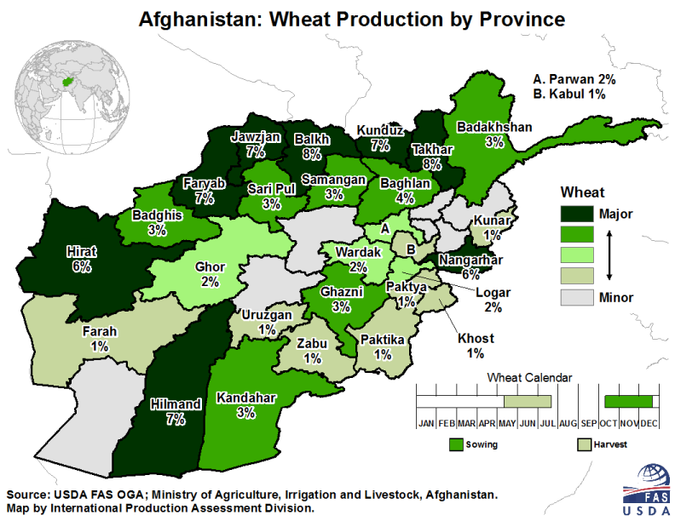
Figure 1. Shows a clear view of Afghanistan.
DISCUSSION
Authors should discuss the results and how it can be interpreted from the perspective of previous studies and of the working hypotheses (Rani & Kumar, 2019). The findings and their implications should be discussed in the broadest context possible. Future research directions may also be highlighted (Wakiyama, 2016). The result should be started from the main work until sporting results and must be equipped with a discussion. Results and discussion may also be divided into concise and informative sub-headings if required. The significance of the work should be explored.
CONCLUSION
This section is mandatory, with one paragraph to conclude and summarize the main contents of the articles and to highlight the final outcome of the research. The author(s) may also propose future work and further study at the end of the conclusion section. This section can be added to the manuscript if the discussion is unusually long or complex.
ACKNOWLEDGMENT: Acknowledgments of institutions, individuals, grants, funds, etc. should be placed in a separate section ofthe Manuscript. The names of funding organizations should be written in full.
CONFLICT OF INTEREST: All authors express no conflict of interest in any part of the research.
FUNDING: This research received no external funding.

AUTHORS CONTRIBUTIONS:
Conceptualization, methodology, software, analysis, investigation, resources, original draft preparation, review and editing, visualization, supervision, project administration and funding acquisition. All authors have read and agreed to the published version of the manuscript.

REFERENCES
References should be written in the American Psychological Association (APA) style.
American Psychological Association. (year). Article title: Capital letter also for subtitle. Name of Journal, volume#(issue#), pg#-pg#.
Author(s) of essay or chapter. (year). Title of essay or chapter. In F. M. Lastname (Ed.), Book title (pages of essay or chapter). Publisher. https://doi.org/10.xx.xxxxxxxxxx
Use the American Psychological Association (APA) style as given here:
Kakar, K., Nitta, Y., Asagi, N., Komatsuzaki, M., Shiotsu, F., Kokubo, T., & Xuan, T. D. (2019). Morphological analysis on comparison of organic and chemical fertilizers on grain quality of rice at different planting densities. Plant Production Science, 22(4), 510-518.
Rani, R., & Kumar, N. (2019). On the causal dynamics between economic growth, trade openness and gross capital formation: evidence from BRICS countries. Global Business Review, 20(3), 795-812.
Wakiyama, Y. (2016). The relationship between SPAD values and leaf blade chlorophyll content throughout the rice development cycle. Botany, 12, 329-334.

